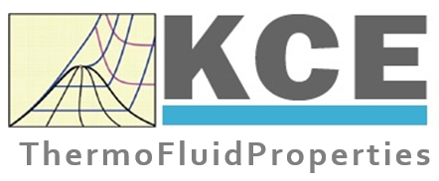 |  | KCE-ThermoFluidProperties UG  Prof. Dr. Hans-Joachim Kretzschmar  Wallotstr. 3  01307 Dresden, Germany  Email: info@thermofluidprop.com  Phone: +49-351-27597860  Phone mobile: +49-172-7914607  Fax: +49-3222-1095810

Inquiry for Property Calculation Libraries
First name, Surname: ___________________________________
Company / Institution: ___________________________________
Street: ___________________________________
ZIP code, Town: ___________________________________
Email: ___________________________________
Phone (for consultation): ___________________________________

Ich am interesting in the following property calculation libraries:
___________________________________
___________________________________
___________________________________
___________________________________
___________________________________
for use in the following application programs or equipments:
Number of licenses
FluidEXL for Excel 32 bit 64 bit ……
FluidVBA for Excel VBA 32 bit 64 bit ……
FluidLAB for MATLAB and Simulink ……
FluidMAT for Mathcad ……
FluidPRIME for Mathcad Prime ……
FluidEES for Engineering Equation Solver EES ……
FluidDYM for Dymola and SimulationX (Modelica) ……
FluidVIEW for LabVIEW ……
FluidPYT for Python ……
FluidJAVA for Java ……
FluidCPP and FluidCS for C++ and C# ……
FluidLINUX for Linux ……
FluidMAC and FluidMACEXL for Mac OS and Mac Excel ……
FluidSPS for BECKHOFF SPS systems ……

Please give me a call.
Please send me an offer.

Please send the filled form
- as an email attachment to info@thermofluidprop.com or
- as a Fax to +49-3222-1095810 or
- in a letter to KCE-ThermoFluidProperties UG,
Wallotstr. 3, 01307 Dresden, Germany.

